PABNA UNIVERSITY OF SCIENCE AND TECHNOLOGY



Faculty of Engineering & Technology
Department of Information and Communication Engineering

Course name : Signals and Systems
Course Code : ICE-2203

Assignment On:
- Explain the conditions for the existence of the Fourier transform.
- Why does DFT produce both positive and negative frequencies?
- What is the sampling theorem? Derive the Nyquist rate.
- Define stability in terms of system response.
5. Properties of Fourier Transform.

Submitted By:
Even (Group-1)
Session:2021-22
2nd Year 2nd Semester
Department of ICE, PUST

Submitted To:
Dr. Md. Imran Hossain
Associate Professor
Department of Information and
Communication Engineering,
Pabna University of Science and Technology, Pabna
Date of Submission: 24/02/2025
Even Group-1:
Roll:
- 220604
- 220606
- 220608
- 220612
- 220614
- 220616
- 220618
- 220620
- 220622

- Explain the conditions for the existence of the Fourier transform.
Answer :
The Fourier transform of a function x(t) is given by:
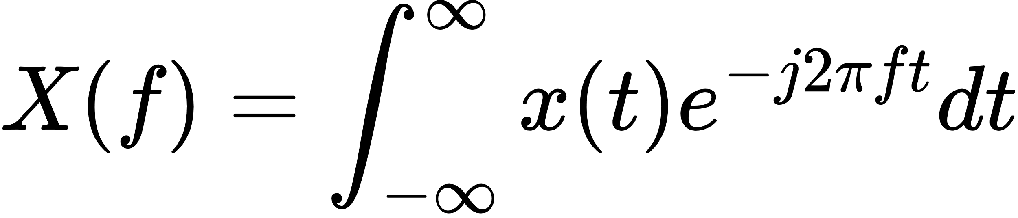
For this integral to exist and converge, certain conditions must be satisfied, known as Dirichlet conditions:

a. Absolute Integrability
The function must be absolutely integrable over the entire time domain:

- This means that the total area under the magnitude of the function must be finite.
- Physically, this implies that the function has finite energy or power, which is necessary for meaningful frequency representation.

b. Finite Number of Discontinuities
- x(t) can have discontinuities, but the number of these discontinuities should be finite in any finite interval.
- The discontinuities must not be infinite jumps (e.g., Dirac delta functions are not allowed).

c. Finite Number of Maxima and Minima
- In any finite interval, the function should have a finite number of maxima and minima.
- This ensures that the function is not oscillating infinitely in a finite region, which would make the integral divergent.

d. Piecewise Continuity
- The function should be piecewise continuous, which means it can have discontinuities, but between these points, it must be continuous.
- Each piece should be finite and well-behaved.

Example :
The function :
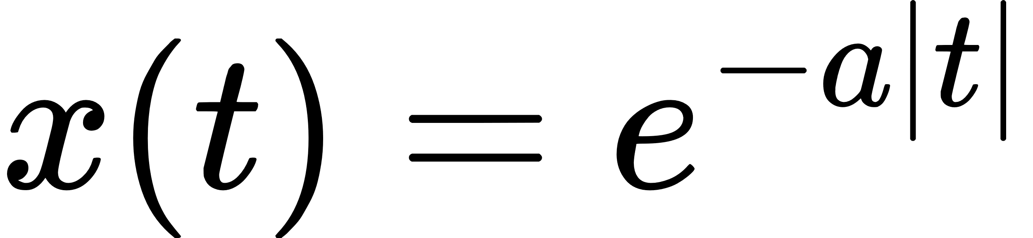
where a>0, satisfies all these conditions:
- It is absolutely integrable because its area converges.
- It is continuous everywhere.
- It has no discontinuities or infinite oscillations.
Therefore, its Fourier transform exists.

- Why does DFT produce both positive and negative frequencies?
Answer :
The DFT of a discrete-time signal x[n] is given by:
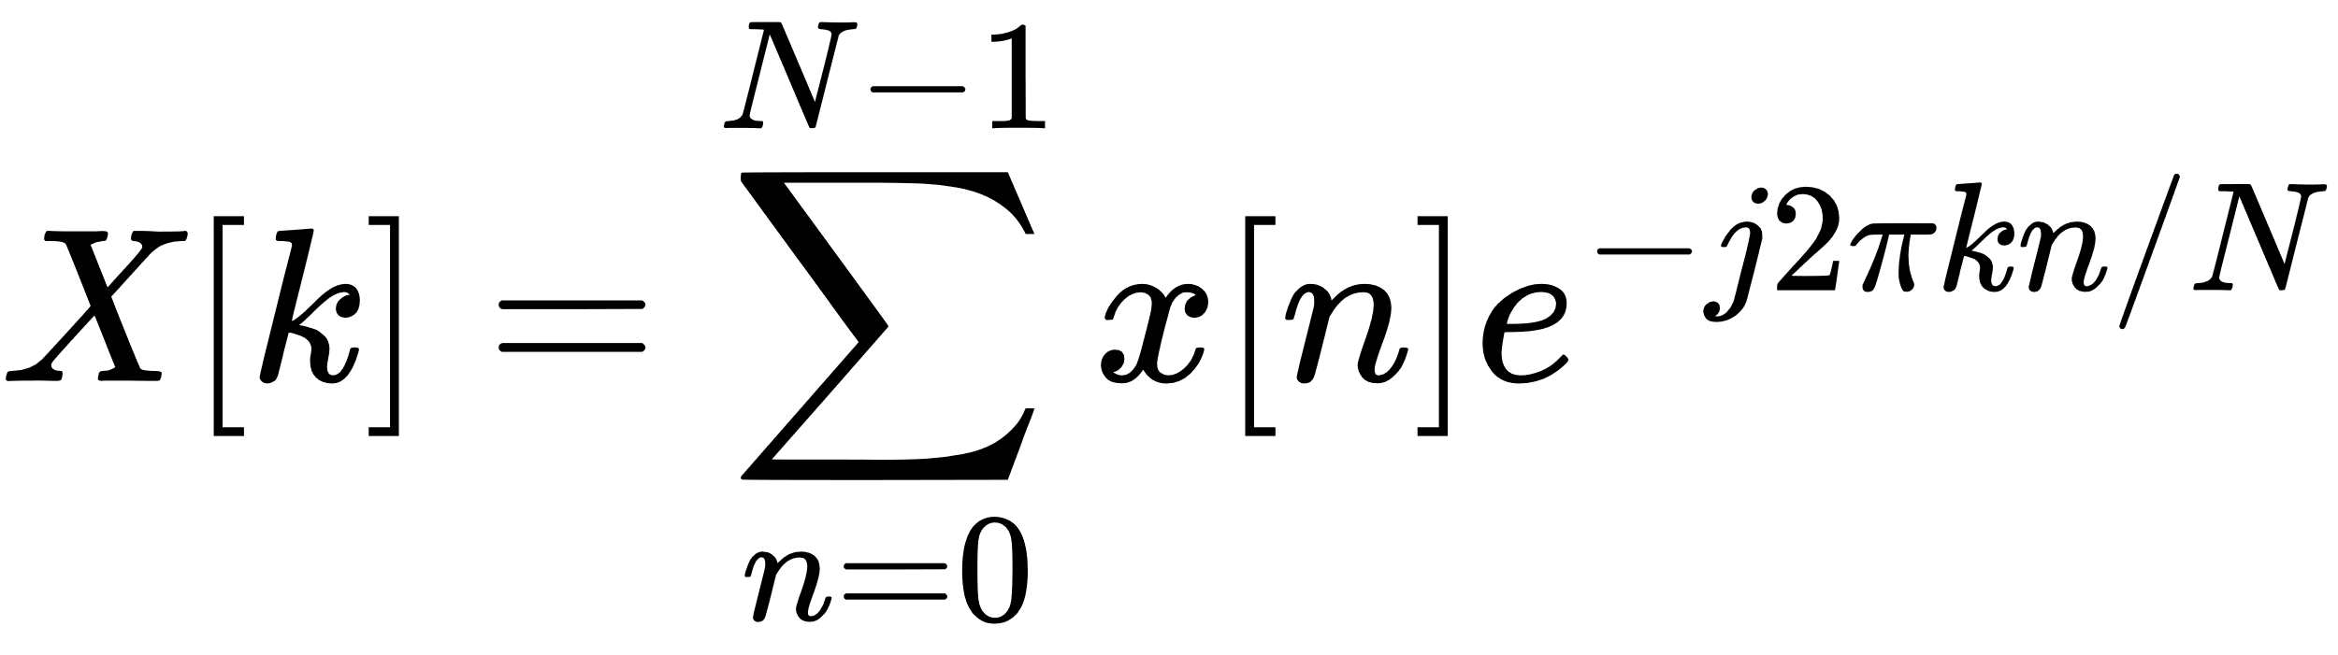
- Here, k represents the frequency index, and N is the total number of samples.
- The resulting X[k] is periodic with period N.
- The DFT uses complex exponentials 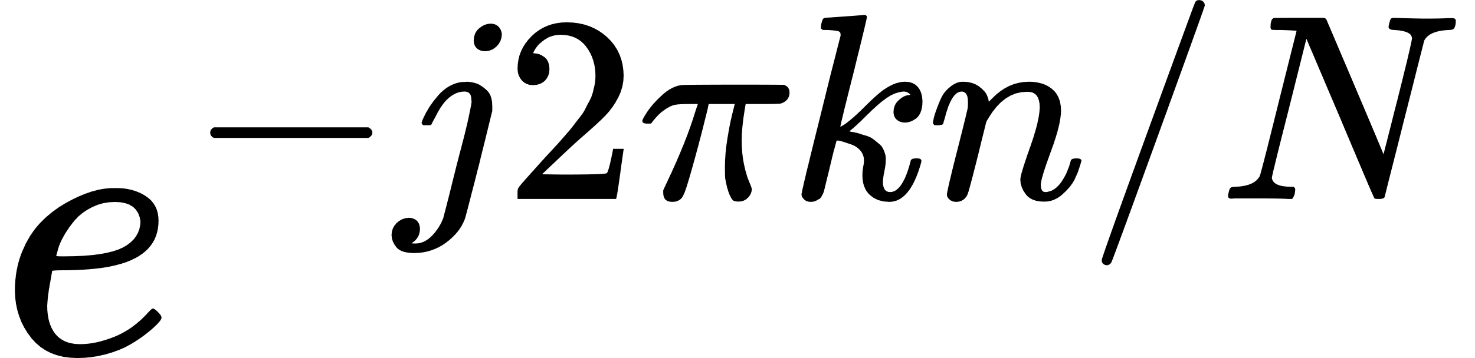 as basis functions, which can be expanded using Euler's formula:
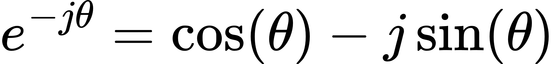
- This complex form inherently represents both positive and negative frequencies:
  - Positive frequencies correspond to counterclockwise rotation in the complex plane.
  - Negative frequencies correspond to clockwise rotation.

Symmetry in DFT :
- Due to the periodic nature of the DFT, the frequency components are symmetric. Specifically:
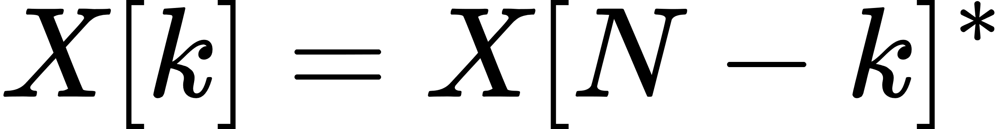
- This conjugate symmetry shows that negative frequencies are just the mirror images of positive frequencies.
- In practice, the negative frequencies are not "real" but represent phase information, helping to fully reconstruct the time-domain signal.

Example :
For a real-valued input x[n] , the DFT exhibits conjugate symmetry:
- X[1] corresponds to a positive frequency.
- X[N−1] corresponds to a negative frequency of the same magnitude but opposite phase.

- What is the sampling theorem? Derive the Nyquist rate.
Answer :
The Sampling Theorem, also known as Nyquist-Shannon Sampling Theorem, states:
- A band-limited continuous-time signal x(t), having no frequency components higher than f_{max} , can be completely represented by its samples and perfectly reconstructed if the sampling rate is at least twice the highest frequency component.
- Mathematically, if X(f) is the Fourier transform of x(t) and X(f)=0 for ∣f∣ > f_{max} , then the sampling frequency f_{s} must satisfy:
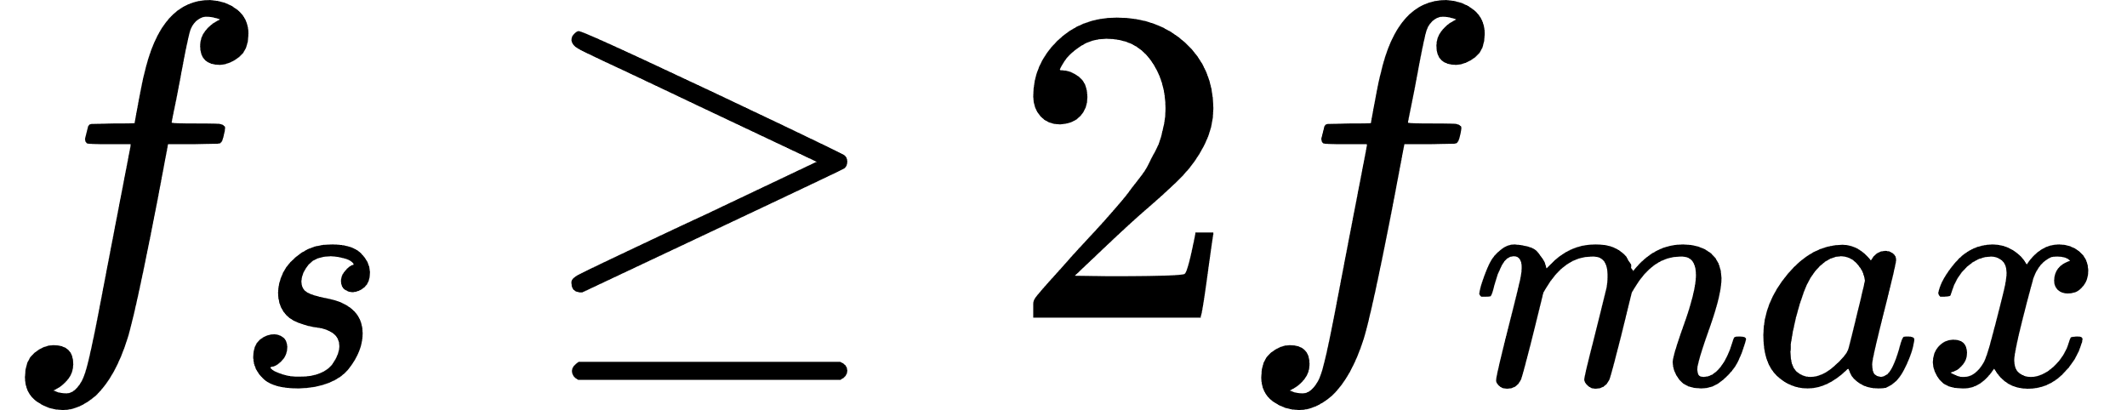
This minimum sampling rate is known as the Nyquist Rate.

Derivation of Nyquist Rate :
- Fourier Transform of the Continuous Signal:
Consider a band-limited signal x(t) with Fourier transform X(f), which is nonzero only in the range −f_{max} to f_{max}.
- Sampling Process:
The sampled signal is:
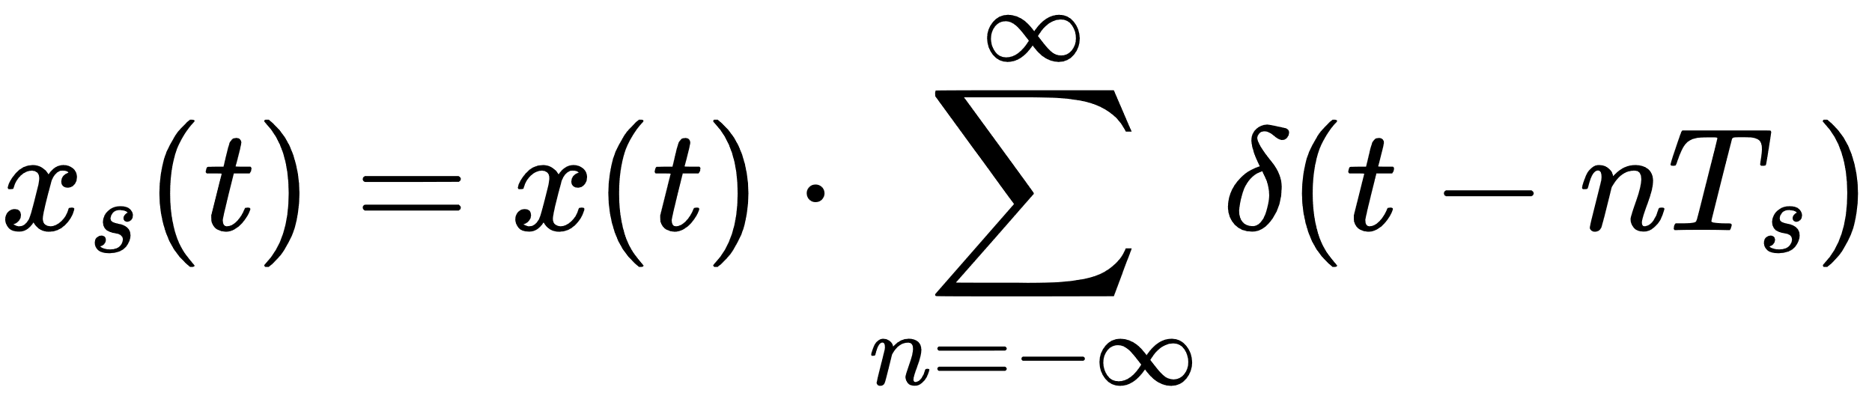
Where ,
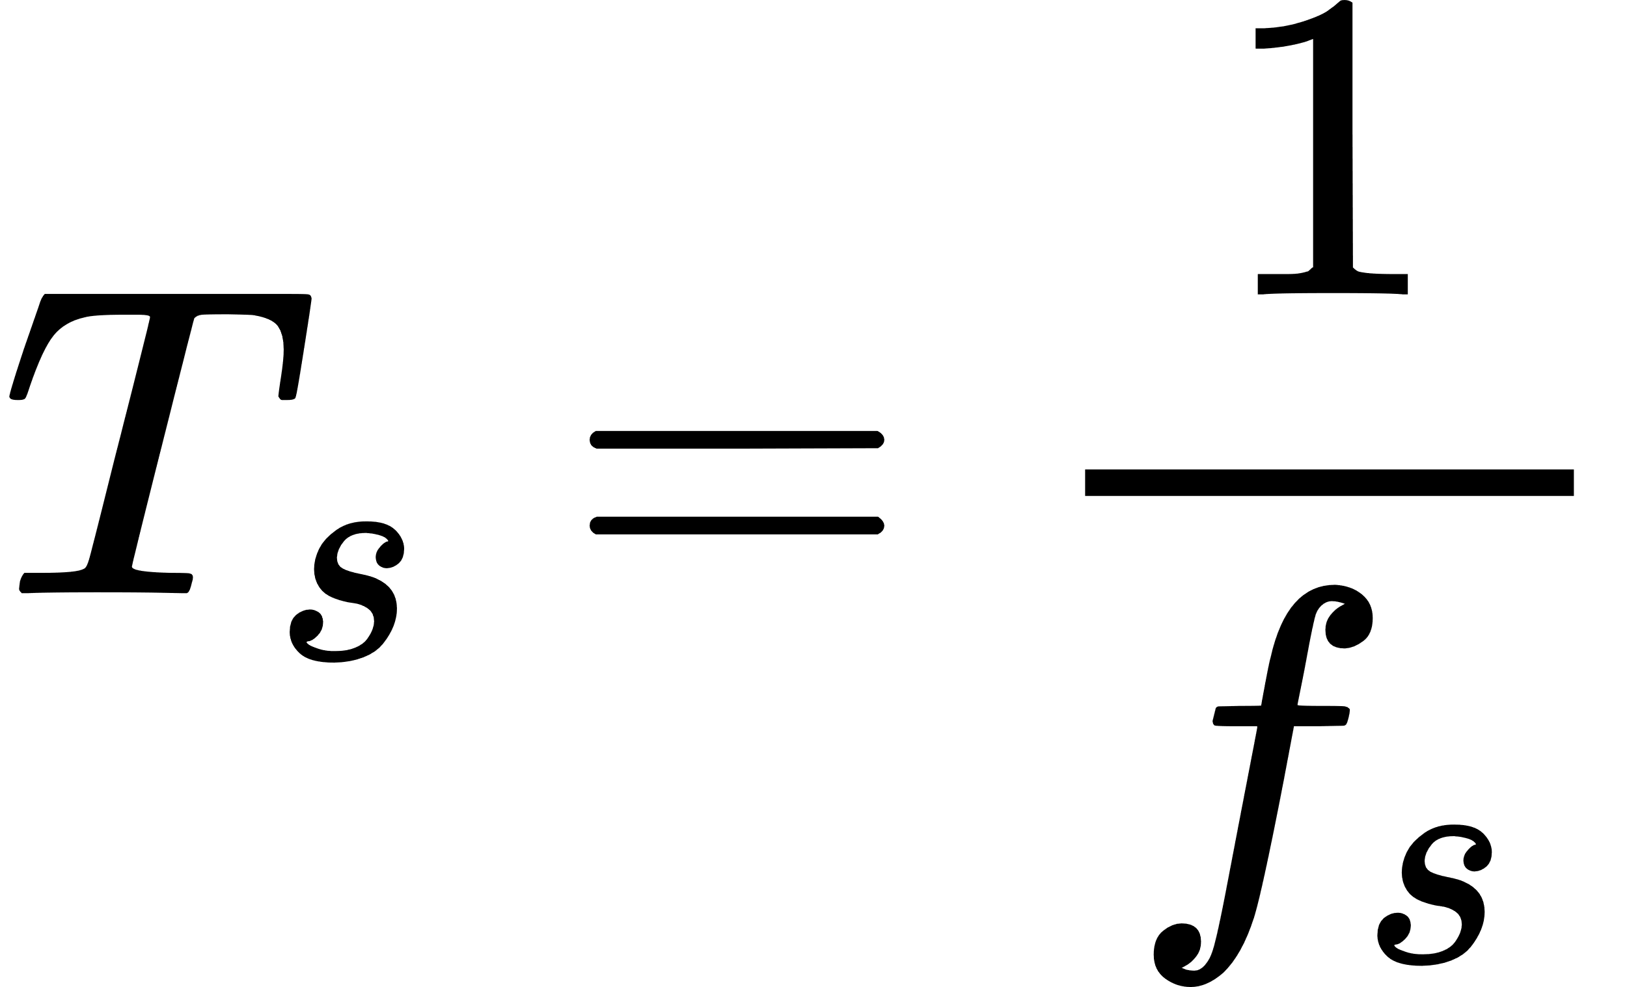​ is the sampling interval.
- Fourier Transform of Sampled Signal:
The Fourier transform of the sampled signal is:
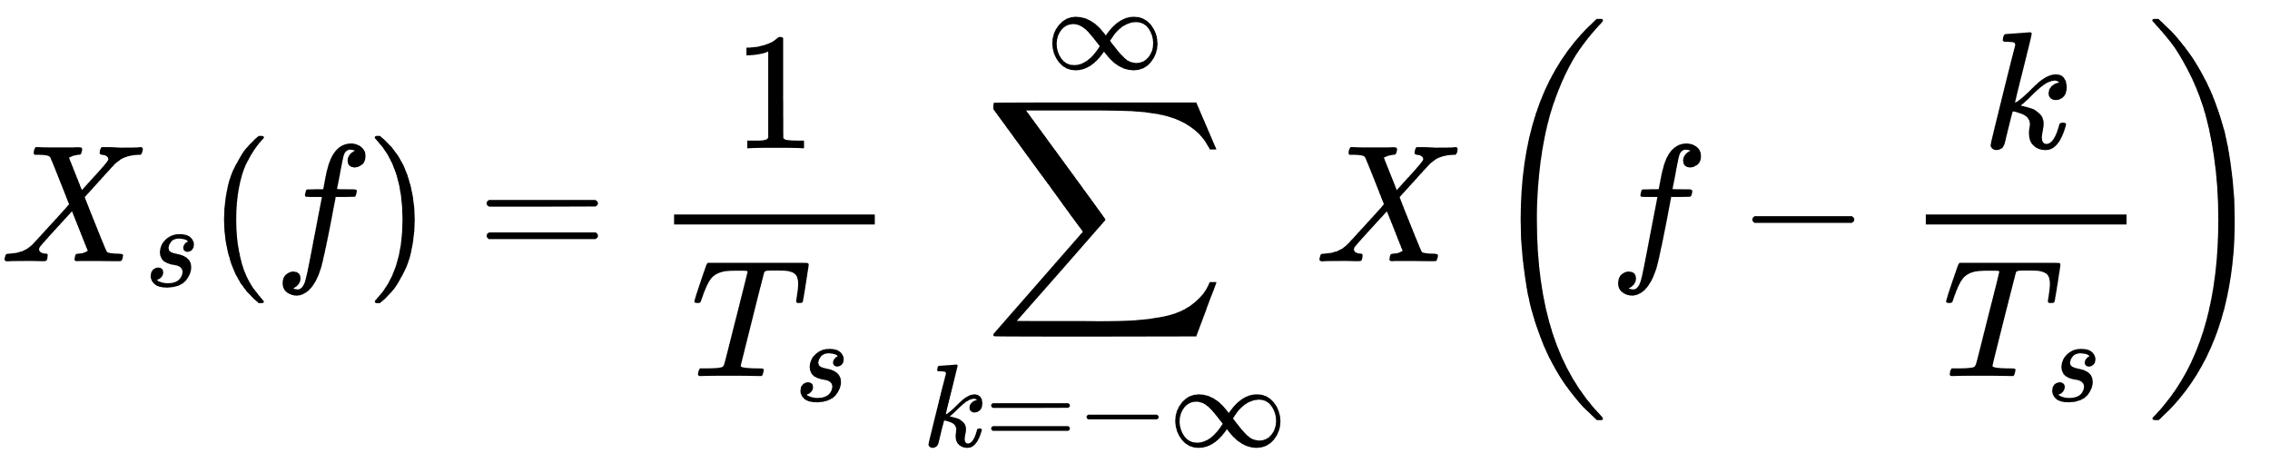
This shows that the spectrum of x(t) repeats periodically with period f_{s}.
- Avoiding Aliasing:
To avoid overlap of these repeated spectra (aliasing), we require:
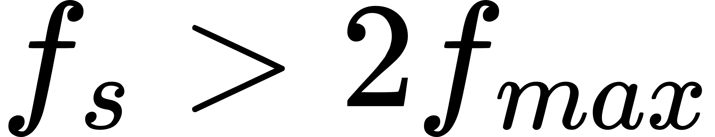
The minimum value for f_{s} that satisfies this inequality is called the Nyquist Rate:

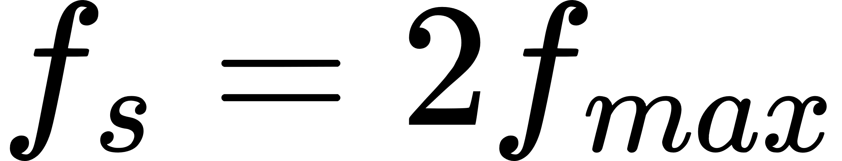

Example :
If the maximum frequency of a signal is 5 kHz, then the Nyquist rate is:
f_{s} ≥ 2×5 = 10 kHz
4. Define stability in terms of system response.
Answer :
A system is stable if its output remains bounded for any bounded input. Mathematically:
- If the input x(t) is bounded, i.e., ∣x(t)∣ < M_{x} for some finite M_{x}, then the output y(t) should also be bounded, i.e., ∣y(t)∣ < M_{y}​ for some finite M_{y}.
Or,
where M_{x} and M_{y} are finite constants.

For Linear Time-Invariant (LTI) systems, stability is determined using the Impulse Response h(t):
- The system is stable if:
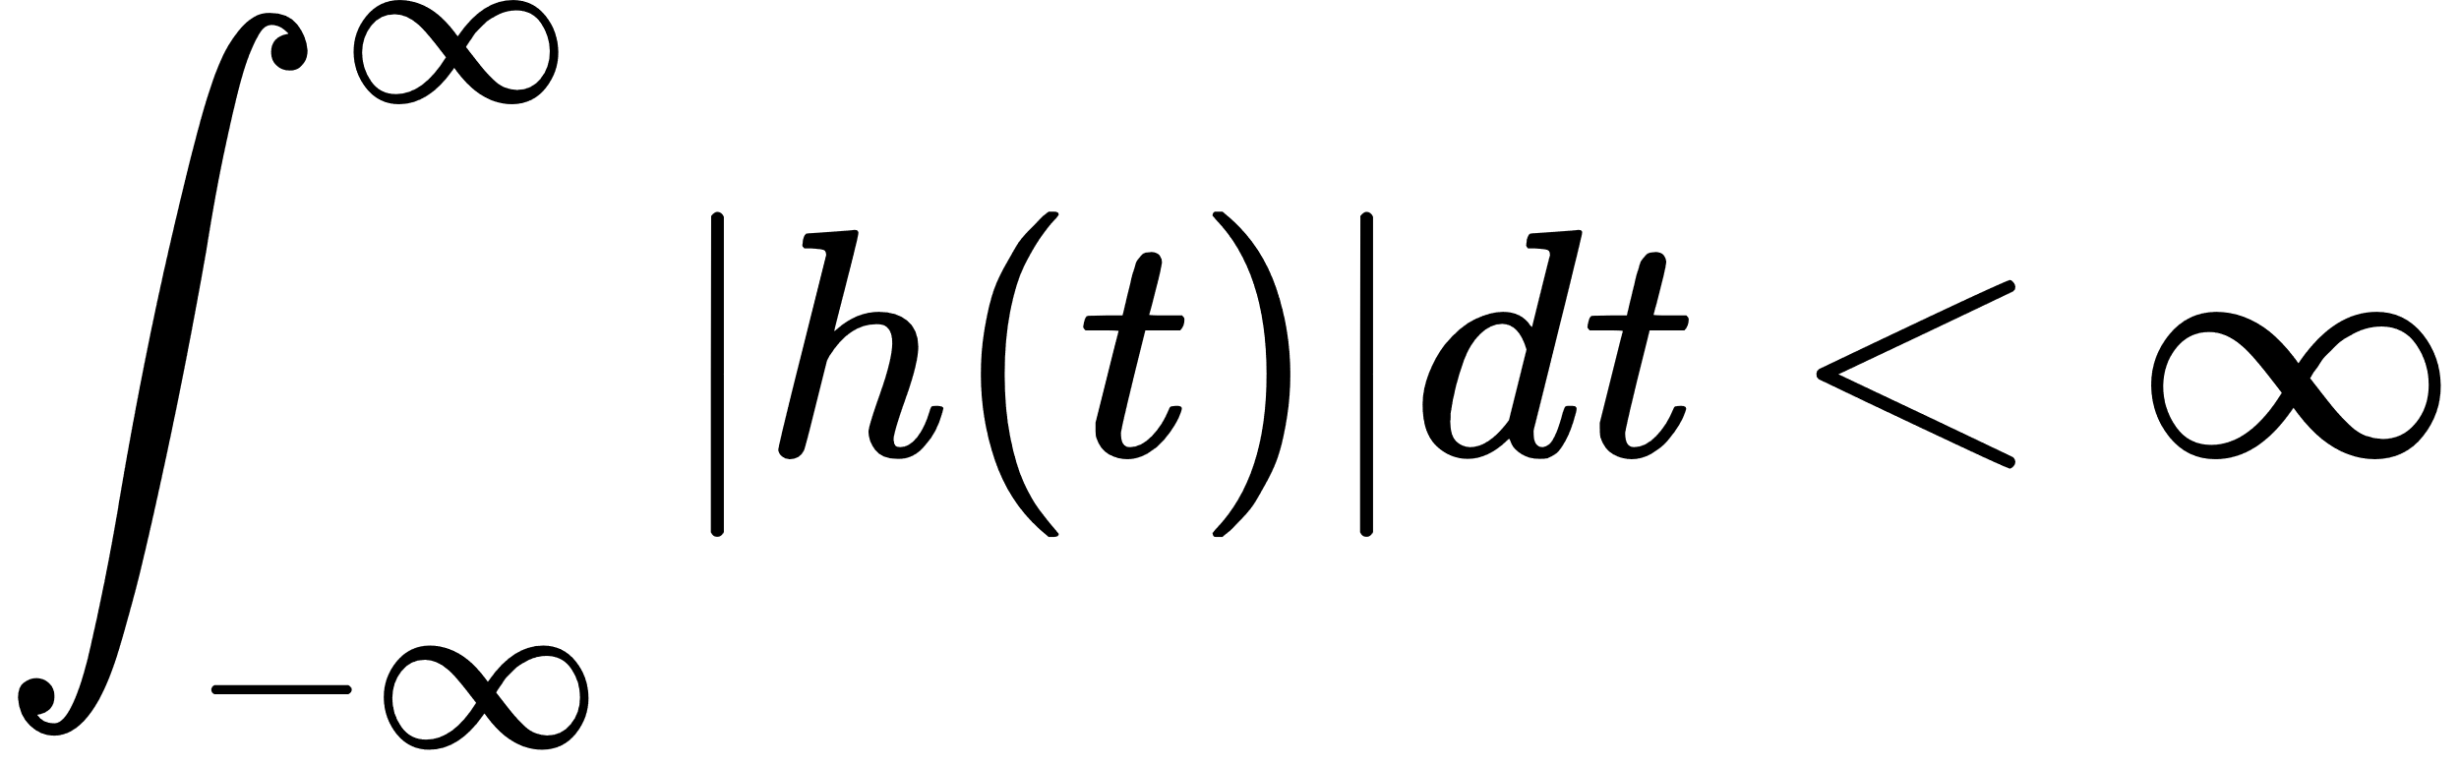
- This means the total energy of the impulse response should be finite.

Example :
The system with impulse response h(t) = e^{-at} is:
- Stable if a > 0 because the integral converges.
- Unstable if a ≤ 0 because the integral diverges.

5. Properties of Fourier Transform
The Fourier Transform has several important properties:
(i) Linearity
$$F\left[c_{1}x_{1}\left(t\right)+c_{2}x_{2}\left(t\right)\right]=\int_{-∞}^{∞}{\left[c_{1}x_{1}\left(t\right)+c_{2}x_{2}\left(t\right)\right]e^{-jωt}dt}$$
$=c_{1}\int_{-∞}^{∞}{x_{1}\left(t\right)e^{-jωt}dt}+c_{2}\int_{-∞}^{∞}{x_{2}\left(t\right)e^{-jωt}dt}$
$=c_{1}X_{1}\left(ω\right)+c_{2}X_{2}\left(ω\right)$
Scaling and addition in the time domain correspond to the same operations in the frequency domain.
(ii) Time Shifting
$$\text{If }x\left(t\right)↔X\left(ω\right),\text{ then }x\left(t-c\right)↔X\left(ω\right)e^{-jωc}\text{ for any constant }c.$$
$$Proof:[F\left[x\left(t-c\right)\right]=\int_{-∞}^{∞}{x\left(t-c\right)e^{-jωt}dt}$$
$$=\int_{-∞}^{∞}{x\left(t\right)e^{-jω\left(t+c\right)}dt}$$
$$=e^{-jωc}\int_{-∞}^{∞}{x\left(t\right)e^{-jωt}dt}$$
$$=X\left(ω\right)e^{-jωc}.$$
A shift in the time domain introduces a phase shift in the frequency domain.
(iii) Frequency Shifting
$$\text{If }x\left(t\right)↔X\left(ω\right),\text{ then }x\left(t\right)e^{jω_{0}t}↔X\left(ω-ω_{0}\right)\text{ for any }real ω_{0}.$$
$$Proof:[F\left[x\left(t\right)e^{jω_{0}t}\right]$$
$$=\int_{-∞}^{∞}{x\left(t\right)e^{jω_{0}t}e^{-jωt}dt}$$
$$=\int_{-∞}^{∞}{x\left(t\right)e^{-j\left(ω-ω_{0}\right)t}dt}$$
$$=X\left(ω-ω_{0}\right).$$

Multiplying by an exponential shifts the spectrum.
(iv) Time Revising
$$F\left[f\left(-t\right)\right]=\int_{-∞}^{∞}{f\left(-t\right)e^{-jωt}dt}$$
$=\int_{t=-∞}^{t=∞}{f\left(-t\right)e^{-jωt}dt}$
$=\int_{t=-∞}^{t=∞}{f\left(t\right)e^{jωt}d\left(-t\right)}=\int_{t=∞}^{t=-∞}{f\left(t\right)e^{jωt}d\left(-t\right)}$
$=-\int_{t=-∞}^{t=∞}{f\left(t\right)e^{jωt}dt}$
$$=\int_{-∞}^{∞}{f\left(t\right)e^{jωt}dt}=F\left(-jω\right)$$
Scaling in time compresses or expands the frequency spectrum.
(v) Modulation Theorem
$$If(x\left(t\right)↔X\left(ω\right)),then[x\left(t\right)\cos\left(ω_{0}t\right)↔\frac{1}{2}\left[X\left(ω+ω_{0}\right)+X\left(ω-ω_{0}\right)\right].$$
$$F\left[x\left(t\right)\cos\left(ω_{0}t\right)\right]=F\left[\frac{1}{2}x\left(t\right)\left(e^{jω_{0}t}+e^{-jω_{0}t}\right)\right]$$
$$=\frac{1}{2}F\left[x\left(t\right)e^{jω_{0}t}\right]+\frac{1}{2}F\left[x\left(t\right)e^{-jω_{0}t}\right]$$
$$=\frac{1}{2}\left[X\left(ω-ω_{0}\right)+X\left(ω+ω_{0}\right)\right].$$
Convolution in the time domain corresponds to multiplication in the frequency domain.
(vi) Convolution Theorem
$$If(x\left(t\right)↔X\left(ω\right))and(v\left(t\right)↔V\left(ω\right)),then[x\left(t\right)⋆v\left(t\right)↔X\left(ω\right)V\left(ω\right).$$
$$Proof:[F\left[x\left(t\right)⋆v\left(t\right)\right]=\int_{-∞}^{∞}{\left[x\left(t\right)⋆v\left(t\right)\right]e^{-jωt}dt}$$
$$=\int_{-∞}^{∞}{\left(\int_{-∞}^{∞}{x\left(λ\right)v\left(t-λ\right)dλ}\right)e^{-jωt}dt}$$
$$=\int_{-∞}^{∞}{x\left(λ\right)\left(\int_{-∞}^{∞}{v\left(t-λ\right)e^{-jωt}dt}\right)d}$$
$$=\int_{-∞}^{∞}{x\left(λ\right)V\left(ω\right)e^{-jωλ}d}$$
$$=V\left(ω\right)\int_{-∞}^{∞}{x\left(λ\right)e^{-jωλ}dλ}=X\left(ω\right)V\left(ω\right).$$

